THE REMAKING OF TOWN LAKECHAMP
  - CHAPTER 1: FIRST, WE REBUILD
Interactive Storybook

Nyasha Grace Chikanga 101 340 984
Project 1 Design Document
ITEC 1401 Into to Scripting and Problem Solving
Winter 2026

Design Document v1.0
31/01/26

Project overview
  - Executive Summary
This game will be an interactive story about restoring a small town called Lakechamp to its natural state. Mini games to challenge the reader and have them help with the rebuild will be presented on certain pages. This document provides the mechanics of the game.

Main Narrative
  - 2.1 Story (1 point)
A story about a town that went through an unfortunate incident. The buildings are in disrepair, and the residents of the town have been displaced and are scattered
  - 2.2 Visual Style (0.5 point)
The illustrations and other visual elements are 2d and the style uses vibrant colors and minimalist shapes
The visual art style will be heavily inspired by the games ‘Angry Birds’, ‘Among Us’, and ‘Thank Goodness You’re Here!’.
The environment will be a small town that has been wrecked and is in the process of being repaired.
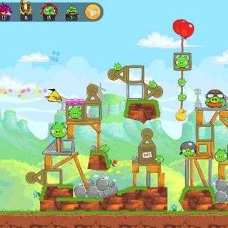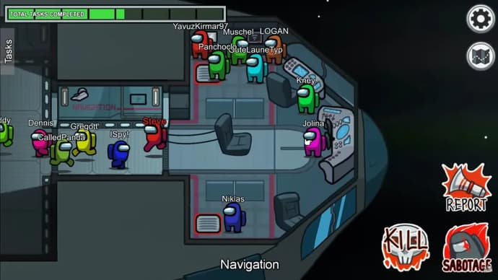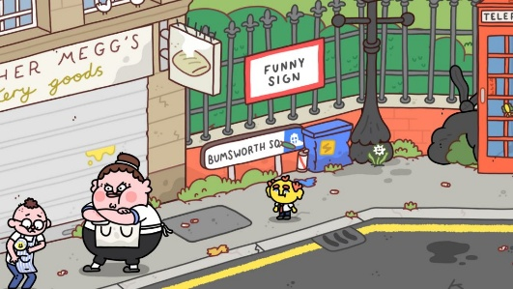
(From left to right: ‘Angry Birds’, ‘Among Us’, ‘Thank Goodness You’re Here!’)
  - 2.3 Interactive Elements (0.5 point)
There will several interactive elements, some of which will be passive and others will be active, requiring action from the player/reader to be triggered.
Active interactions:
Navigational arrows
Game pieces
Restart button
Passive interactions:
Smoke
Residents
Game pieces
  - 2.4 UI (0.5 point)
The story and games are meant to be read and played on a PC. The UI will feature bright and vibrant colors. The user will be able to control the pages, start and restart the games, request hints to complete challenges, as well as access a tutorial.
  - 2.5 Concept Art (0.5 point)
The art will look similar to these three well known and commercially successful games
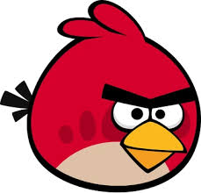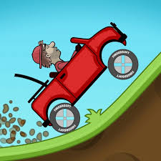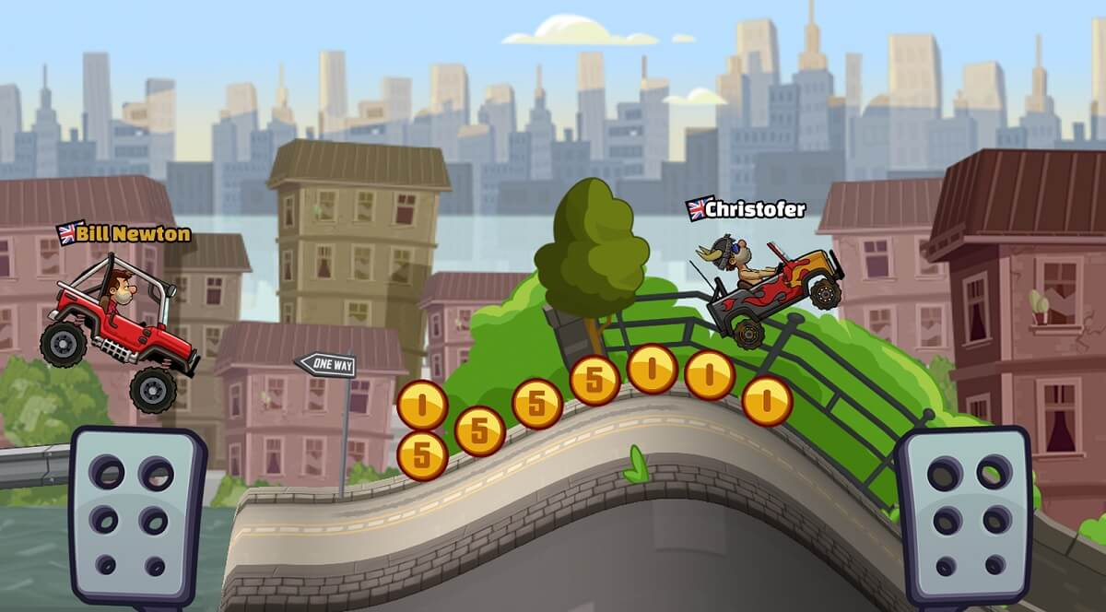
(From left to right, ‘Angry Birds’, ‘Among Us’, ‘Hill Climb Racing’)
(‘Hill Climb Racing’)

Mini-Games
  - 3.1 At least 3 games (2 points each)
Each mini-game symbolizes a stage of Town Lakechamp’s recovery, reinforcing the theme of rebuilding and community restoration through interactive gameplay.
Puzzle:
The player must complete the puzzle with the map of the town. This is the first game and is the most important, it shows the ideal state of the town.
Guess the pin:
A simple game where the player tries to guess a string of numbers. The game says higher/lower to guide the player. This number is the pin to lowering the lift bridge which is the only access to the town.
Road crossing:
An arcade game where the player’s goal is to move a character through a series of busy roads, dodging moving vehicles and obstacles, leading the character home.
Slot placement:
A minimalist 2D puzzle game where the player moves and places in game characters into limited spaces, trying to fit everyone without overlapping or running out of room. This is to symbolize residents returning to their respective apartments.

  - 3.2 Story Starter (0.5 point)
Page 1
The streets of Lakechamp were once filled with laughter, but after disaster struck, only broken buildings and empty homes remained.
Page 2
The residents were displaced, the town left in disarray, and the future uncertain. Now the residents are trying to get back on their feet.
Page 3
Thankfully the team of engineers, builders, and city planners that built the town have returned to help with the restoration efforts.
  - 3.3 Gameplay (0.5 point)
Restore the Town Map - (Puzzle):
Complete the puzzle with the map of the town. Drag and drop map pieces into the correct positions. Pieces will snap in to place when positioned correctly. All map pieces must be placed correctly to win.
Lower the Bridge - (Guess the pin):
Guess a string of numbers. Enter a number guess, the game will respond with ‘Higher’ or ‘Lower’ to guide your next guess. Continue guessing until the correct pin is found. The correct number must be guessed to lower the bridge, granting access to the town to win.
Get Home Safely – (Road crossing):
Move a character through a series of busy roads, dodging moving vehicles and obstacles, and lead a resident home. Tap (up, left, right, down) arrow keys to move the character forward, left, right, or down. Time your movements carefully to cross safely. The resident must reach home safely to win.
(Slot placement):
Move and place characters into limited spaces without overlapping or running out of room. Use arrow keys to control characters that continuously move, one character at a time into the apartment slots. All residents must be placed successfully to win

  - 3.4 Visual Style (0.5 point)
The visual style of the games will resemble that of the story. The illustrations and other visual elements are 2d and the style uses vibrant colors and minimalist shapes
The visual art style will be heavily inspired by the games ‘Angry Birds’, ‘Among Us’, and ‘Thank Goodness You’re Here!’.
The environment will be a small town that has been wrecked and is in the process of being repaired.
(From left to right: ‘Angry Birds’, ‘Among Us’, ‘Thank Goodness You’re Here!’)

  - 3.5 Features (0.5 point)
Environment:
The story and games focus on one town and everything that the player will encounter will have to do with something within the town.
Characters:
The player will be able to take on the role of at least one in game character and control at least one resident at one point in a game.
Gameplay:
The games will be about experiencing the rebuilding efforts of the town; thus the games will be logic based and target critical thinking skills.

Among Us Character
https://i.pinimg.com/736x/22/9a/05/229a05f9751700bd4445a6f90477dc03.jpg

Among Us Game Screen
https://encrypted-tbn0.gstatic.com/images?q=tbn:ANd9GcTib71uPWFSTJmBuBrk84KFAnciL4yIUGcorg&s

Angry Birds Red Bird
https://www.google.com/url?sa=i&url=https%3A%2F%2Fwww.angrybirds.com%2Fcharacters%2Fred%2F&psig=AOvVaw3UkADIXLPmI6Dlcx53RhO2&ust=1769918611002000&source=images&cd=vfe&opi=89978449&ved=0CBUQjRxqFwoTCOjbh_TytJIDFQAAAAAdAAAAABAE

Angry Birds Game Screen
https://i.guim.co.uk/img/media/05ddaeadc2a8491b539df4720d59960924e940af/0_0_2070_1242/master/2070.jpg?width=1200&height=900&quality=85&auto=format&fit=crop&s=7df5b6e903c73058208ee4a5b9fad87b

Hill Climb Racing Car
https://store-images.s-microsoft.com/image/apps.27192.9007199266379485.c1ef97c5-cf2f-4dbd-840d-c4c975f1b009.4c147b04-721a-4ac1-b7e9-151ad255f3f3

Hill Climb Racing Game Screen
https://gamesbeat.com/wp-content/uploads/2025/05/hill-climb-racing-2-3.jpg

Thank Goodness You’re Here.
https://encrypted-tbn0.gstatic.com/images?q=tbn:ANd9GcSKICPICDaNb2X38sGNcof336PNCsZNUKxnjA&s

